**Gel-Blocking Protocol**

**Gelatin Solution ~3 cubes**

* *Sucrose (C12H22O11) 5 g*
* *Gelatin type A 6 g*
* *MilliQ water (H2O) 50 mL*

**Solutions needed**

*4% PFA 20 mL*

*30% sucrose solution 20 mL*

**Materials needed**

150 mL beaker

Falcon tubes

Hot plate

Ice cube tray

Magnetic stir bar & retriever

Metal spatulas (two sizes)

Thermometer

**Protocol**

1. Add water, magnetic stir bar, and thermometer to a 150 mL beaker.
2. Using a hot plate, heat water to ~40°C with the heat element set at 1.
   1. Place the falcon tube with the brain on the heat element as well so that the brain can slowly begin to heat up.
   2. Make sure the temperature does not exceed 45°C.
3. Add sucrose and stir until completely dissolved. Remove the thermometer.
4. Slowly add gelatin and stir for 5 minutes or until completely dissolved.
5. Turn off heat and let sit for 10 minutes to remove bubbles. Remove stir bar.
6. Pour gelatin solution into an ice cube mold to ~1/3 full to form a base.
   1. Use a metal spatula to remove and/or move any bubbles away to the side.
7. Put the ice cube tray into the freezer at -20°C until it just starts to solidify – this takes ~5 minutes total. After 3 minutes, check on the gelatin every 30 seconds to a minute so that it can be removed from the freezer as soon as possible.
   1. Gently tilt the tray to test the consistency of the gelatin; remove tray as soon as gelatin is no longer runny.
8. Place the brain on top of the gelatin base and pour gelatin solution over top.
   1. Use a metal spatula to move the brain to the center of the mold (dorsal side up). Remove and/or move any bubbles away to the side.
9. Put the ice cube tray back into the freezer for 20 minutes.
10. Remove the tray. Using a metal spatula, carefully cut around and remove the gel-block from the mold.
11. Trim the gel block into a cube and cut the LEFT edge of the gelatin on the dorsal side of the brain, caudal end facing up. See photos 1-3 for how to orient the brain.
12. Place the gel-blocked brain in a falcon tube containing 20 mL of 4% PFA for 2 hours.
13. Move the gel-blocked brain to a falcon tube containing 30% sucrose solution. Place on the rotator until it sinks (>2 hours) or store in the fridge overnight.

**Photo 1.**

Side view – right hemisphere shown

Caudal

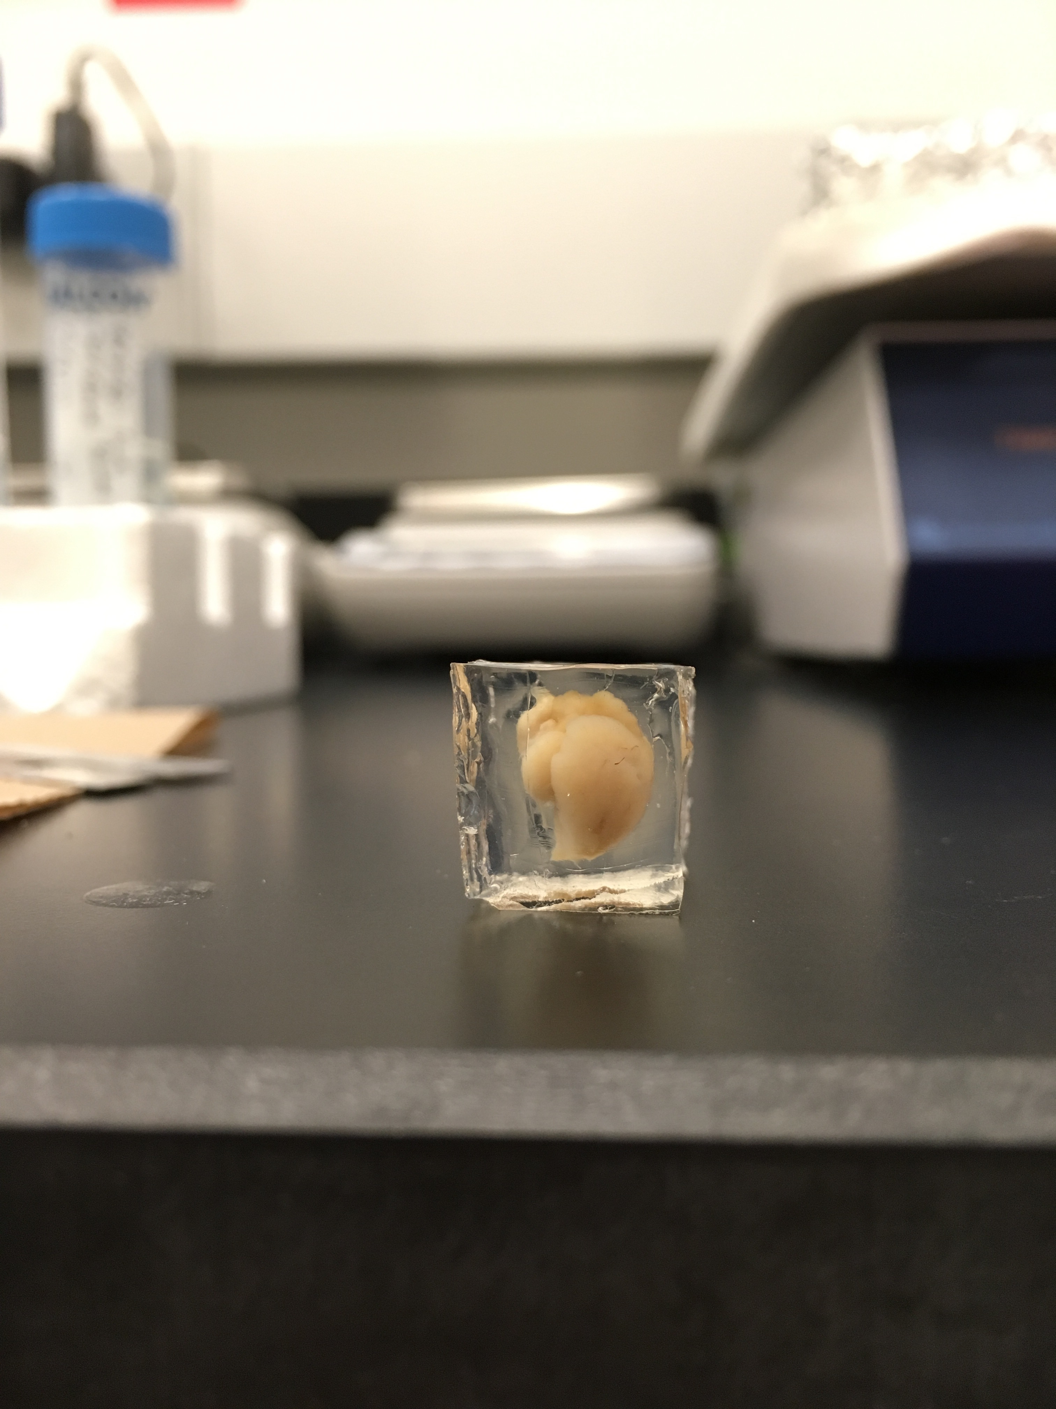

Dorsal

Ventral

Rostral

**Photo 2.**

Caudal

Side view – dorsal side shown

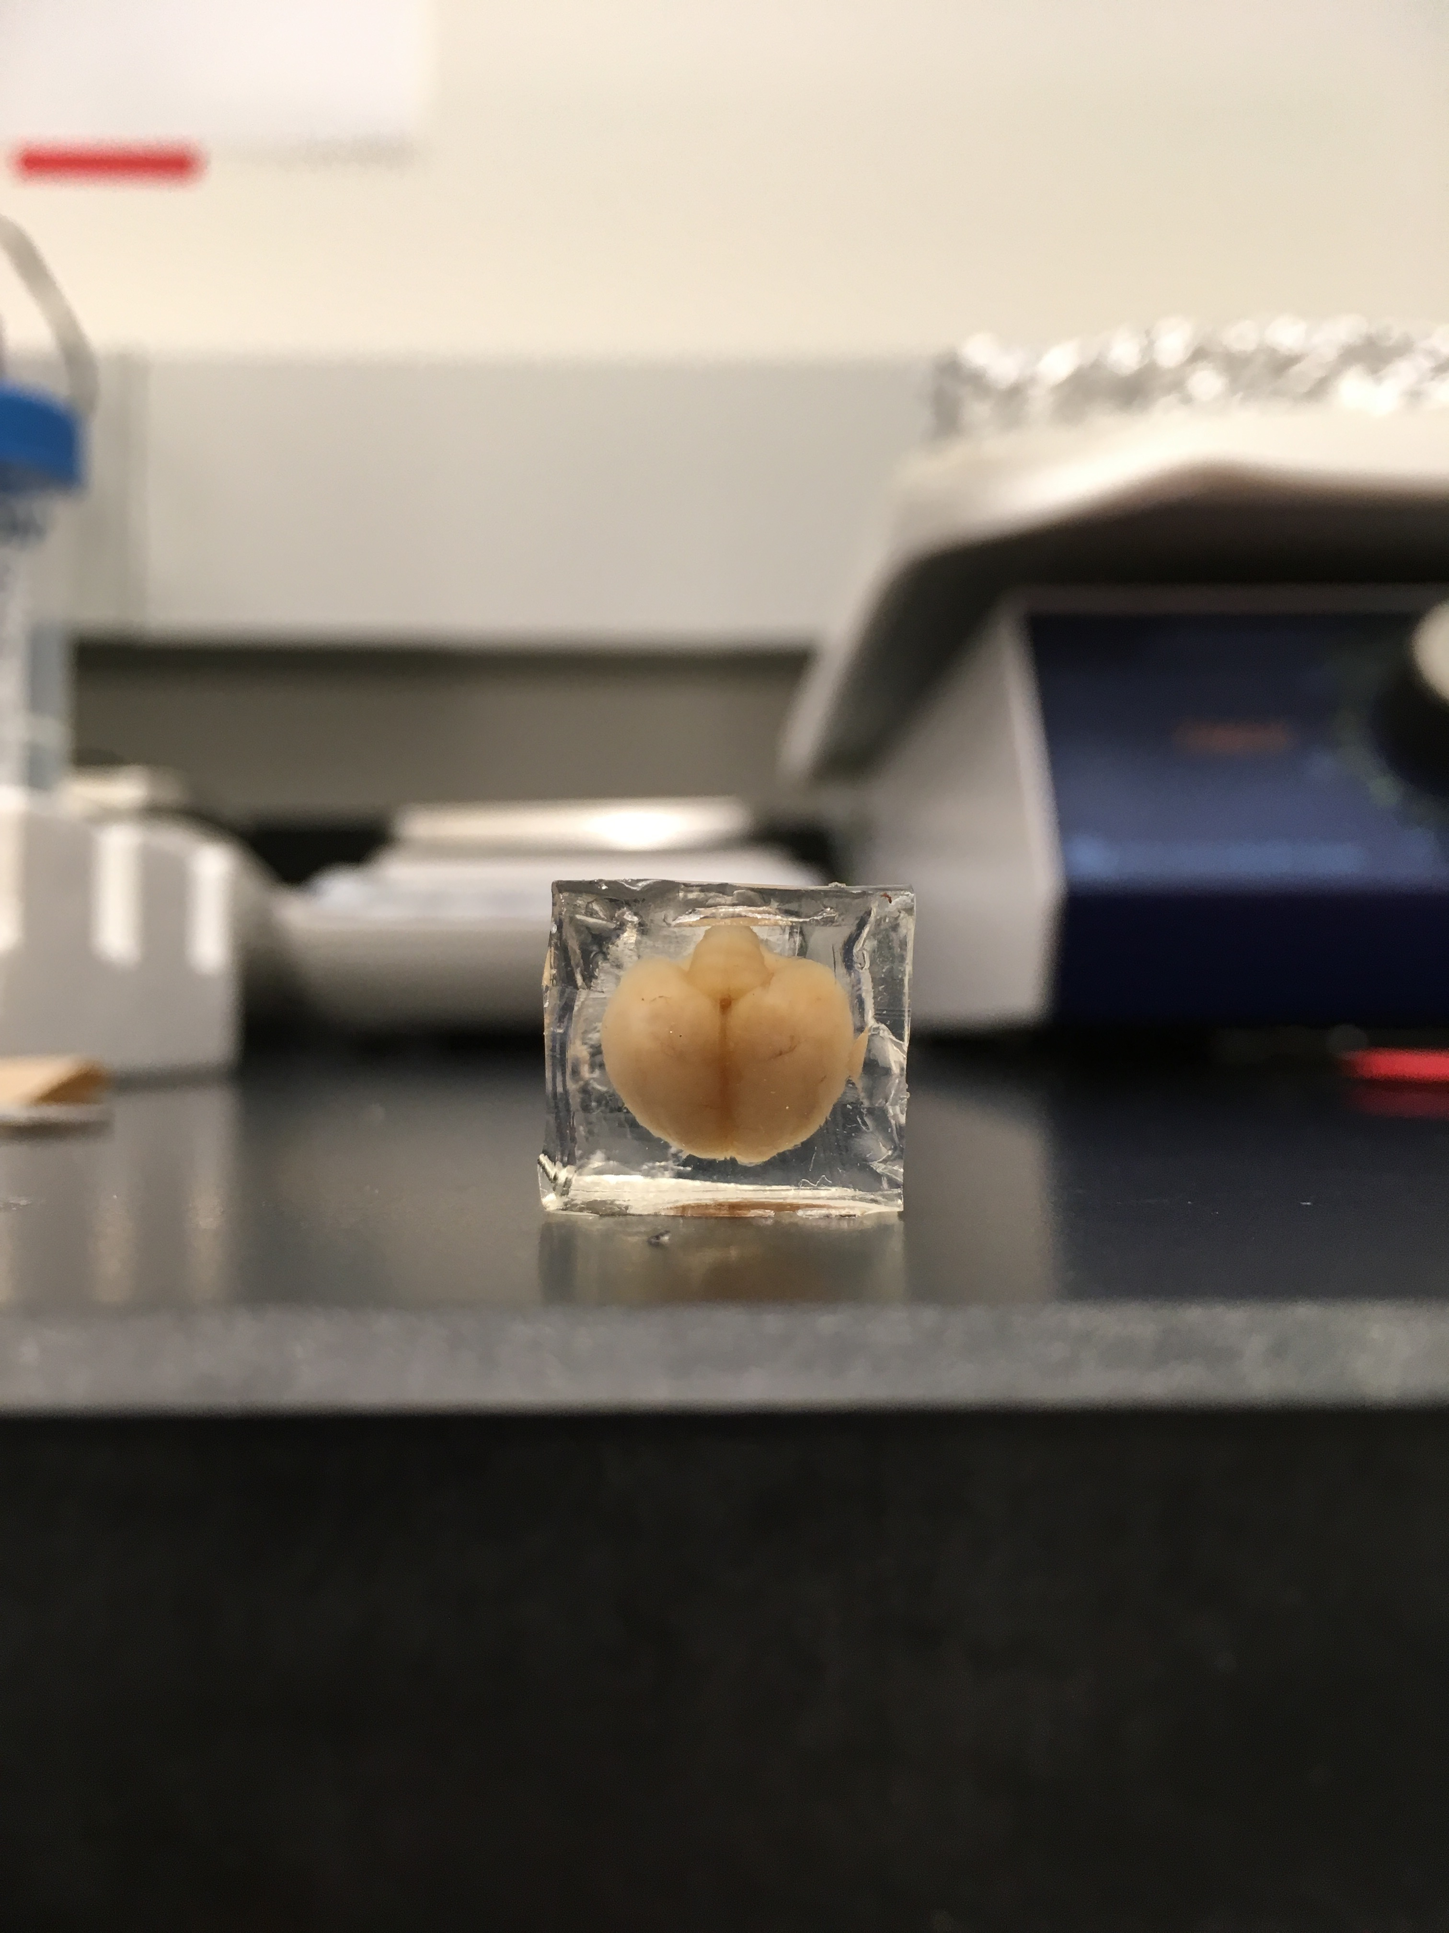

Left hemisphere

Right hemisphere

Rostral

**Photo 3.**

Dorsal

Top view – caudal side shown

Cut along dashed line

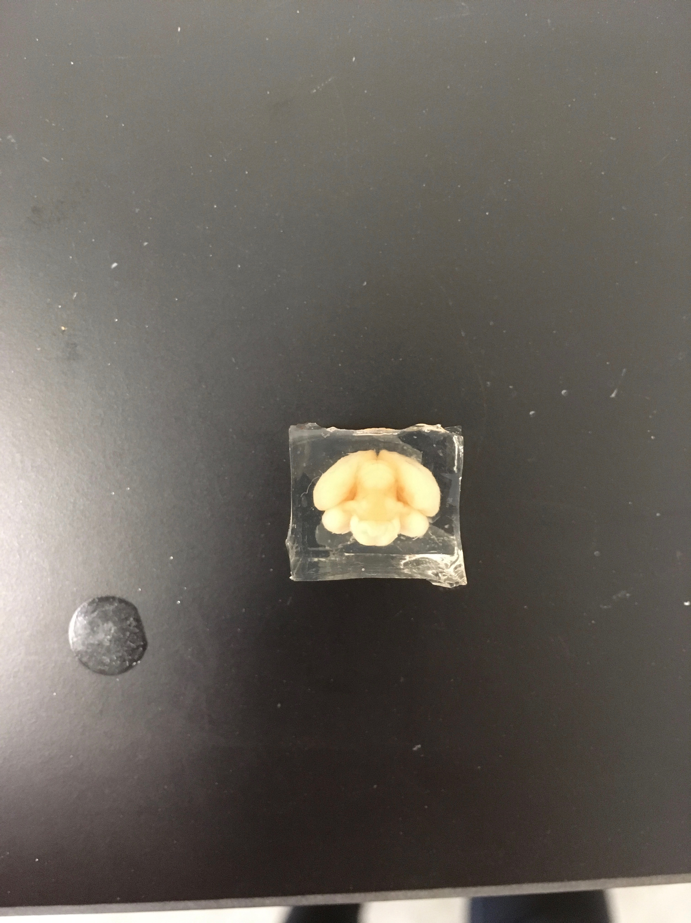

Right hemisphere

Left hemisphere

Ventral